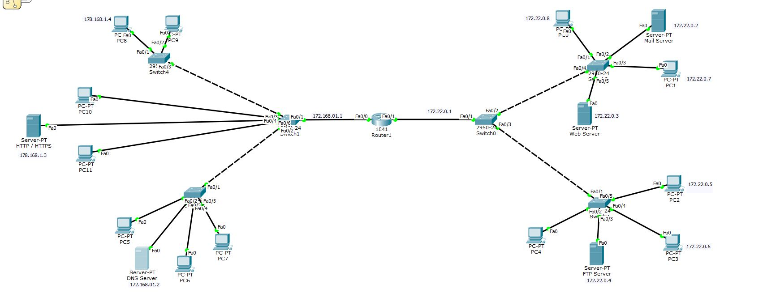

Router Config

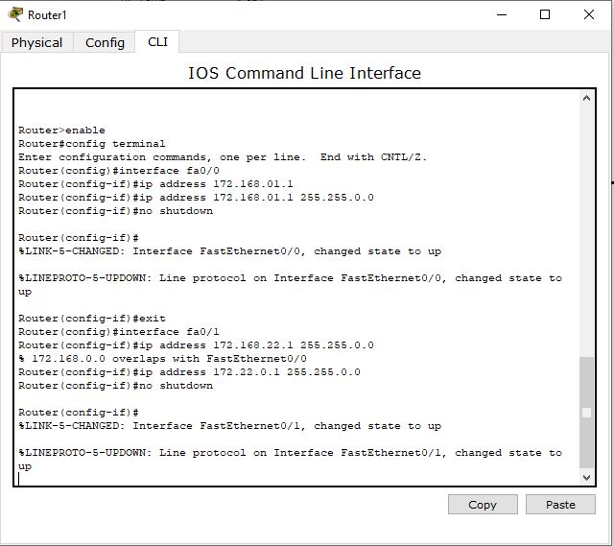

DNS Config

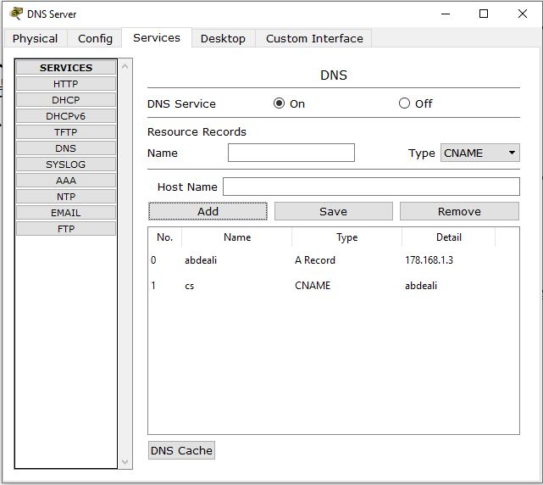

FTP Config

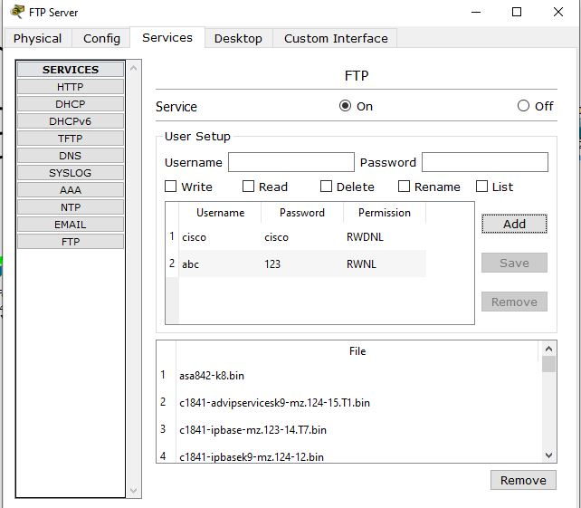

FTP PUT AND GET

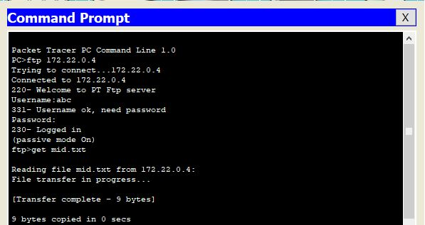

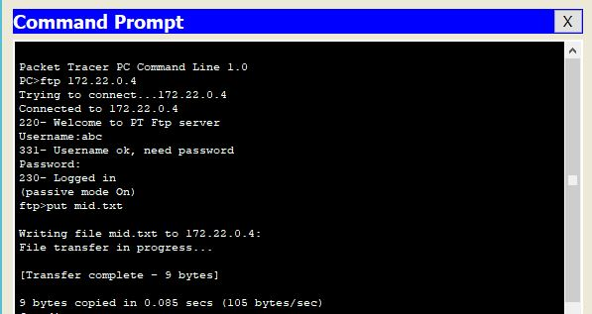

SMTP Config

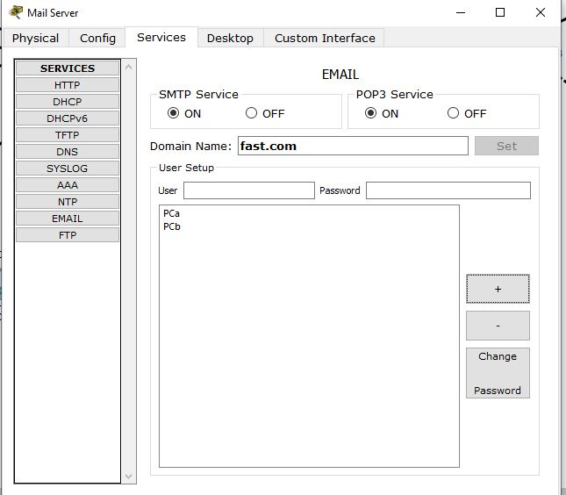

Email Config for both pc

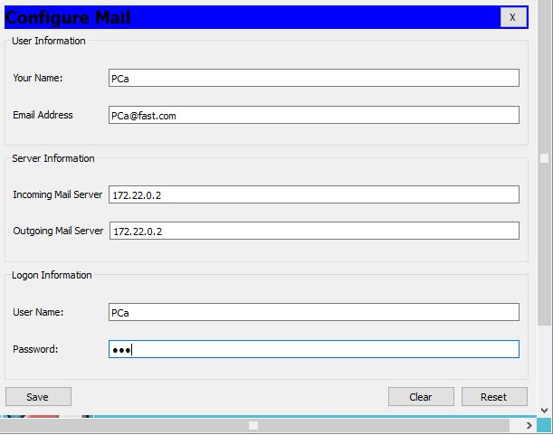

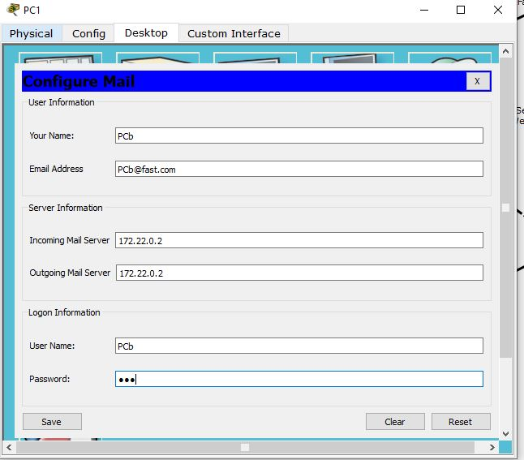

Sent from PC

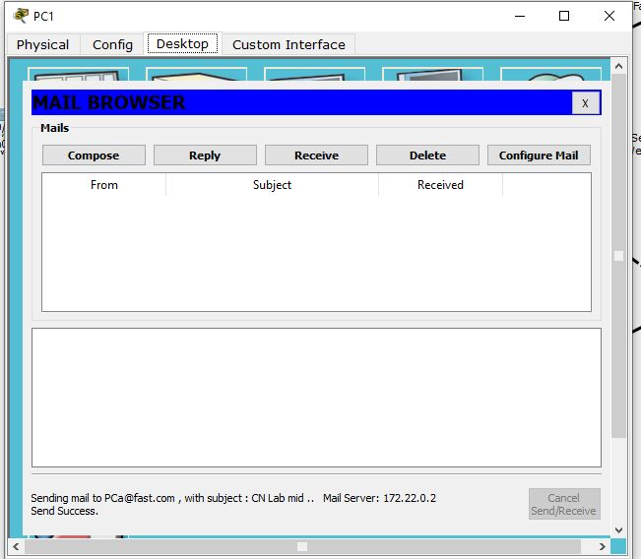

Receive to PC

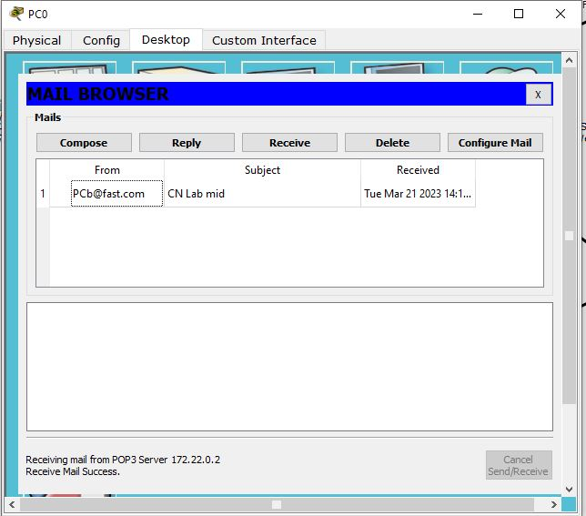

Server.py

import socket as sock

HOST = "127.0.0.1"

PORT = 5300

with sock.socket(sock.AF_INET, sock.SOCK_STREAM) as s:

  s.bind((HOST, PORT))

  s.listen()

  conn, addr = s.accept()

  with conn:

    print(f"Connected by {addr}")

    while True:

      data = conn.recv(1024)

      print(f"Msg recieved from the client: {data}")

      if not data:

         break

      conn.sendall(bytes(input() , encoding= 'utf8'))

Client.py

import socket

HOST = "127.0.0.1"

PORT = 5300

with socket.socket(socket.AF_INET, socket.SOCK_STREAM) as s:

    s.connect((HOST, PORT))

    while True:

        s.sendall(bytes(input() , encoding= 'utf8'))

        data = s.recv(1024)

        if not data:

            break

        print(f"Received data from server : {data}")

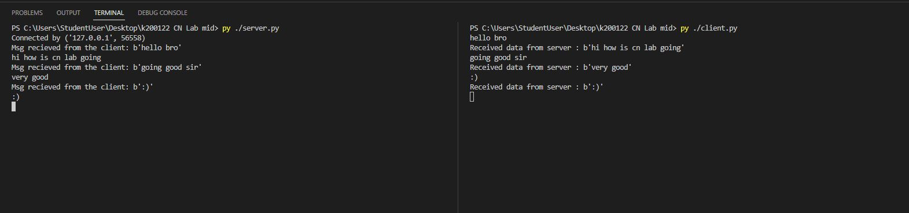Communication

Wire Shark

Q1) Source IP: 172.16.33.87 Destination IP : 172.16.5.46

Q2) Query Domain Name : google.com

Q3) Source Port : 65314 Destination Port : domain (53)

Q4) Ack Number = 524

Q5) Transaction ID : 0x011e Flag Standard Query : 0x0100 Type name of packet : A

